Assessing the Impact of Environmental and Ecological Factors on the Performance of Fraser Sockeye Salmon Forecasts

Yi Xu1, Qi Liu2, Caihong Fu1

1 3190 Hammond Bay Road, Pacific Biological Station, Fisheries and Oceans Canada, Nanaimo, BC, Canada

2 401 Burrard Street, Pacific Region Head Office, Fisheries and Oceans Canada, Vancouver, BC, Canada

Author information

Author ORCIDs

Yi Xu <https://orcid.org/0000-0002-9902-9588>

Caihong Fu <https://orcid.org/0000-0002-6343-9550>

Corresponding author: Yi Xu

[xuyiouqd@gmail.com](mailto:xuyiouqd@gmail.com); [Yi.Xu2@dfo-mpo.gc.ca](mailto:Yi.Xu2@dfo-mpo.gc.ca)

Supplementary materials

Table S1. List of 37 models under three categories (A: non-parametric/naïve, B: biological, and C: biological models coupled with covariates). Where applicable, models use effective female spawner data (EFS) as a predictor variable.

| **MODEL CATEGORY** | **DESCRIPTION** |
| --- | --- |
| **A. Non-Parametric (Naïve) Models** | |
| LLY | Return from the previous year;, where *Rett-1*is the observed return during the previous year (t-1) |
| R1C | Return from 4 years before the forecast year; , where *Rett-4* is the observed return four years prior to the forecasted return |
| R2C | Geometric mean return from 4 and 8 years before the forecast year; , where *Rett-4* and *Rett-8*are the observed returns four and eight years prior to the forecasted return |
| RAC | Geometric mean return on the forecast cycle line for all years;  , where *t-x* is the first cycle-line year with return data, and n is the number of cycle-line years with return data |
| TSA | Geometric mean return across all years;, where *N* is the number of years with return data |
| RS1 | Product of average survival from 4 years before the forecast year and the forecast brood year EFS; , where *Rt-4*is the recruits resulting from the EFS(*efft-4*) in the brood year four years prior to most recent brood year |
| RS2 | Product of average survival from 4 and 8 years before the forecast year and the forecast brood year EFS; , where *Rt-4*and *Rt-8* are the recruits resulting from the previous two cycle-line brood years (4 & 8 years prior to most recent brood year), and efft-4 and efft-8 are the number of EFS in the previous two cycle-line brood years |
| RS4yr | Product of average survival from the last 4 consecutive years and the forecast brood year EFS; , where *Rt* are the recruits (3, 4, and 5 year old fish) resulting from spawners in the brood year |
| RS8yr | Product of average survival from the last consecutive 8 years and the forecast brood year EFS , where *Rt* are the recruits (3, 4, and 5 year old fish) resulting from spawners in the brood year |
| MRS | Product of average survival for all years and the forecast brood year EFS; , where *Rt* are the recruits (3, 4, and 5 year old fish) resulting from spawners in the brood year and *N* is the number of years with data |
| RSC | Product of average cycle-line survival (entire time series) and the forecast brood year EFS; where *t-x* is the first cycle-line year with data, and *n* is the number of cycle-line years with data. |
| **B. Biological Models** | |
| Ricker | Bayesian Ricker model, loge(*Rt*/ *St*) = *a* – *b* *St* + *Ɛt* |
| RickerCyc | Same as above, using cycle line data only |
| Power | Bayesian power model, loge(*Rt*) = *a* + *b* loge (*St*) + *Ɛt* |
| PowerCyc | Same as above, using dominant year data only |
| Larkin | Bayesian Larkin model, loge(*Rt*) = *a* + *b*1 loge (*St*) + *b*2 loge (*St*) + *b*3 loge (*St*) + *Ɛt* |
| LarkinCyc | Same as above, using cycle line data only |
| Sibling | Bayesian sibling model, loge(*R4, t*) = *a* + *b* loge (*R3, t-1*) + *Ɛt* |
| **C. Biological Models** (B for Ricker or Power) **coupled with Environmental and Ecological Covariates** | |
| B_FRD.mean | B coupled with Mean Fraser discharge flow from April to June |
| B_FRD.peak | B coupled with Peak Fraser Discharge at a given year |
| B_Ei.SST | B coupled with Mean Entrance Island sea-surface temperature (SST) from April to July |
| B_Pi.SST | B coupled with Mean Pine Island SST from May to July |
| B_PDO | B coupled with Pacific Decadal Oscillation in winter preceding outmigration from November to March |
| B_GOA.SST | B coupled with Mean Gulf of Alaska annual SST |
| B_Pink | B coupled with Abundance of pink salmon in the North Pacific Ocean |
| B_Chum | B coupled with Abundance of chum salmon in the North Pacific Ocean |
| B_Sockeye | B coupled with Abundance of sockeye salmon in the North Pacific Ocean |
| B_Salmon.Total | B coupled with Abundance of pink, chum, sockeye salmon altogether in the North Pacific Ocean |

TableS2. Summary of 2021 and 2022 sockeye runs

|  |  |  |  |  |  |  |
| --- | --- | --- | --- | --- | --- | --- |
|  | 2021 | | | 2022 | | |
| Forecast Return | Observed Return | (Observed-Forecast)/Forecast | Forecast Return | Observed Return | (Observed-Forecast)/Forecast |
| Bristol Bay1 | 51,000,000 | 65,860,000 | +29% | 75,270,000 | 79,000,000 | +5% |
| Nass2 | 318,000 | 417,000 | +31% | 471,000 | 487,000 | +3% |
| Skeena3 | 1,690,000 | 1,030,000 | -39% | 2,054,000 | 4,333,344 | +111% |
| Somass4 | 350,000 | 365,000 | +4% | 400,000 | 910,513 | +128% |
| **Fraser River** | **1,330,000** | **2,549,000** | **+92%** | **9,775,000** | **6,836,789** | **-30%** |
| Baker Lake5 | 11,400 | 20,800 | +82% | 27,081 | 25,738 | -5% |
| Lake Washington6 | 24,800 | 38,600 | +56% | 10,165 | 43,289 | +326% |
| Columbia River7 | 155,600 | 151,800 | -2% | 198,700 | 663,253 | +234% |
|  |  |  |  |  | Source: PSC, 2021; PSC, 2022 | |
| 1https://www.adfg.alaska.gov/index.cfm?adfg=commercialbyareabristolbay.harvestsummary | | | | | |  |
| 2https://www.nisgaanation.ca/stock-assessments | | |  |  |  |  |
| 3http://www.pac.dfo-mpo.gc.ca/fm-gp/northcoast-cotenord/skeenatyee-eng.html | | | | | |  |
| 4https://www.roundtables.westcoastaquatic.ca/area-23-barkley-harvest | | | | |  |  |
| 5https://wdfw.wa.gov/fishing/reports/counts/baker-river#returns | | | |  |  |  |
| 6https://wdfw.wa.gov/fishing/reports/counts/lake-washington#sockeye | | | | |  |  |
| 7https://www.fpc.org/webapps/adultsalmon/Q_adultcounts_dataquery.php | | | | |  |  |

Figure S1. The Area (red polygon) where tagged Sockeye salmon (Myers et al., 1996) were captured with numbers showing the months captured Sockeye salmon were tagged. Sea surface temperature was averaged over the polygon and used as a predictor for Sockeye salmon dynamics.

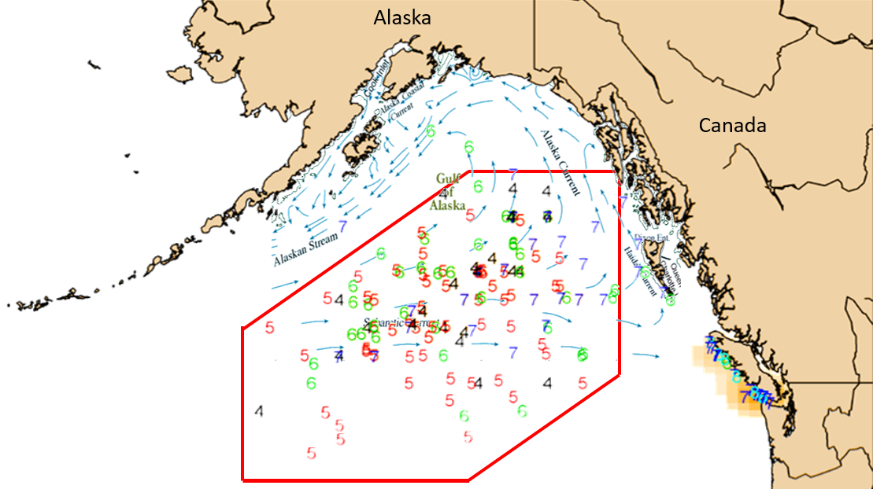

Figure S2. Observed and previously forecasted Fraser sockeye adult returns for the 18 major stocks from 2009 to 2020.

Figure S3. Relative ranking of root-mean-square error (RMSE) of all 37 models for all 18 Fraser sockeye stocks.

Figure S4. Standard deviation for the 2022 forecast model and those for all 37 models for all 18 Fraser sockeye stocks.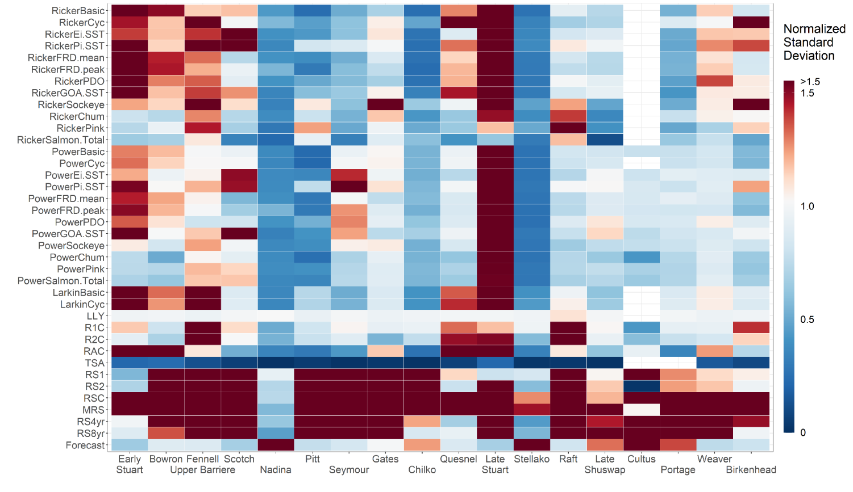

Figure S5. (a) Age 4 Taylor diagram of nine sockeye stocks including Early Stuart and Early Summer run: Bowron, Fennel (Upper Barriere), Scotch, Nadina, Pitt, Seymour, Gates; and Summer run: Chilko. (b) Age 4 Taylor diagrams of nine sockeye stocks including Summer run: Quesnel, Late Stuart, Stellako, Raft; and Late run: Late Shuswap, Cultus, Portage, Weaver and Birkenhead. Each diagram showing comparison of forecasts resulted from models hindcast simulation with actual surveyed returns from 2009-2020. The observed 12 years of returns are normalized as the reference point or observation (solid black cycle on the x-axis). The distance from the origin is the normalized standard deviation with the scale of 0-1.5 and normalized observation being 1. The angle describes the correlation between model and observation from 0 to 1. The dashed semi-circles around reference point on the x-axis illustrate the root-mean-square error. Models with negative correlations are not shown for each stock.

Figure S6. (a) Age 5 Taylor diagram of nine sockeye stocks including Early Stuart and Early Summer run: Bowron, Fennel (Upper Barriere), Scotch, Nadina, Pitt, Seymour, Gates; and Summer run: Chilko. (b) Age 5 Taylor diagrams of nine sockeye stocks including Summer run: Quesnel, Late Stuart, Stellako, Raft; and Late run: Late Shuswap, Cultus, Portage, Weaver and Birkenhead. Each diagram showing comparison of forecasts resulted from models hindcast simulation with actual surveyed returns from 2009-2020. The observed 12 years of returns are normalized as the reference point or observation (solid black cycle on the x-axis). The distance from the origin is the normalized standard deviation with the scale of 0-1.5 and normalized observation being 1. The angle describes the correlation between model and observation from 0 to 1. The dashed semi-circles around reference point on the x-axis illustrate the root-mean-square error. Models with negative correlations are not shown for each stock.

a.

